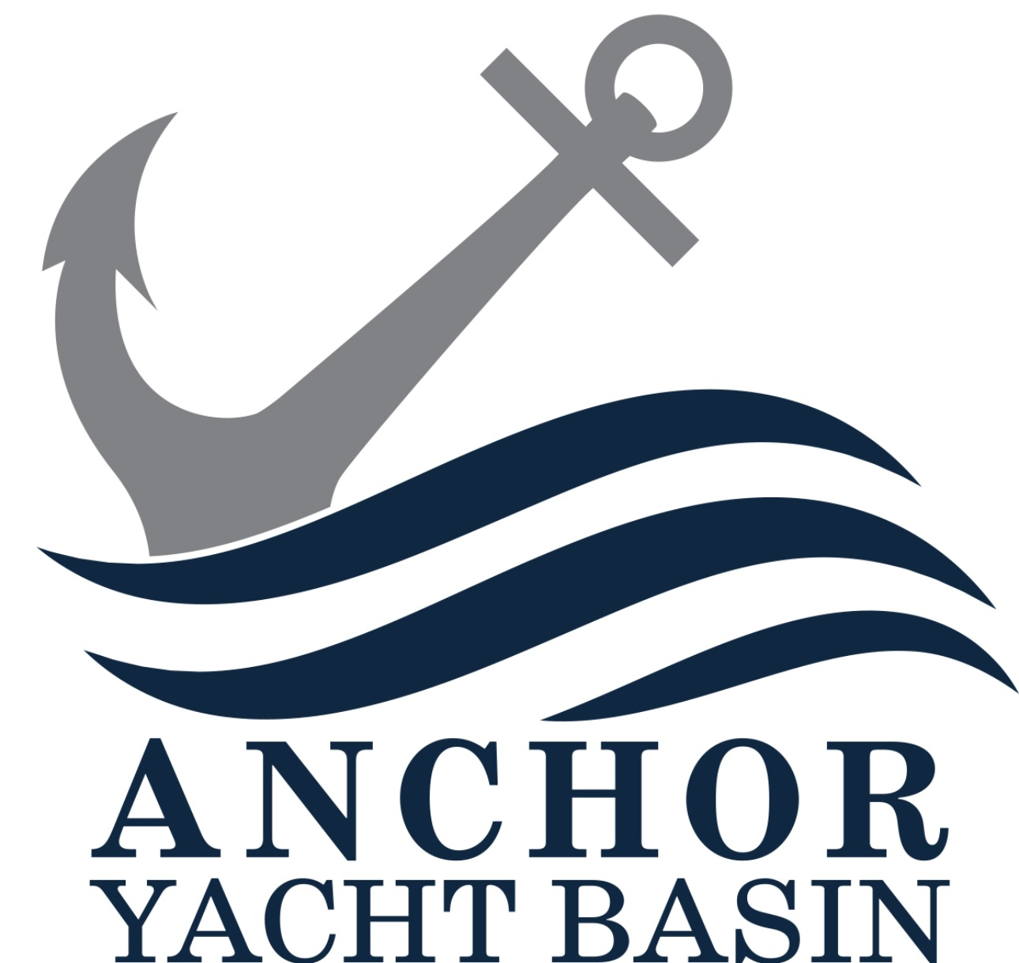

ANCHOR YACHT BASIN MARINA

Subcontractor Rules & Regulations Agreement
This Subcontractor Rules & Regulations Agreement (“Agreement”) is entered into as a condition of performing any work at Anchor Yacht Basin Marina.
1. Access & Authorization
Subcontractors must check in with Marina Management prior to commencing work. Access may be revoked at any time.
2. Scope of Work
Only Marina-approved work is permitted. Deviations require written approval. Bottom Painting is prohibited by subcontractors in Anchor Yacht Basin Marina. All bottom painting must be done in house to comply with clean marina environmental standards.
3. Safety & Conduct
All OSHA, federal, state, and local safety regulations must be followed. Alcohol, drugs, or unsafe conduct are strictly prohibited.
4. Environmental Compliance
Zero tolerance for spills or discharge. All waste must be properly removed.
5. Property Protection
Subcontractors are responsible for damages caused by their work.
6. Vehicles & Parking
Parking is limited to designated areas only.
7. Hours & Noise
Work is limited to approved Marina hours. Monday-Sunday 8am-5pm
8. Insurance
Minimum $1,000,000 General Liability required. Marina must be named Additional Insured and COI must be submitted and approved before starting work.
9. Indemnification
Subcontractor agrees to indemnify and hold harmless Anchor Yacht Basin Marina.
10. Governing Law
This Agreement is governed by Maryland law.

